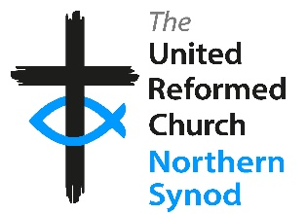
Northern Synod Retreat Booking Form
Please complete this form to apply for a place on a Synod organised retreat.
Guidelines are available in the Synod Retreat Policy (Retreat-Policy-Sept-2024.pdf).
There are various funds available to support attendance at Synod retreats. Please see below for further information.
Basic Details
Name | Click or tap here to enter text.
Church | Click or tap here to enter text.
Your Address | Click or tap here to enter text.
Your Telephone | Click or tap here to enter text.
Your Email  (email is preferred means of communication) | Click or tap here to enter text.

Retreat Details
Retreat Title | Click or tap here to enter text.
Venue | Click or tap here to enter text.
Dates | Click or tap here to enter text.
When did you last attend a Synod retreat? (Please give dates) | Click or tap here to enter text.

How do you propose to cover the cost of attending the retreat?
Self-funded ☐
(you will be sent details of how/where to send your payment)
EM2/3 grant application ☐
(available to Ministers/CRCWs only – please complete form G1)
Retired Ministers training grant application ☐
(available to retired Ministers/CRCWs only via Learning & Development Officer)
Lay Education & Learning Grant ☐
(please complete Individual Lay Education & Learning Grant form)
Other ☐
(Please specify: Click or tap here to enter text.)

